Parallel Implementation of Video-based Obstacle Detection



**C. Balkı GEMİRTER**

CSE 574 - Parallel Processing

January 2021

Table of Contents

Introduction 4

Modules 5

Recording Module 5

Training Module 8

Anomaly Detection in Videos 8

Video Frame Prediction 10

Image Classification 12

IMPLEMENTATION 15

Recording Module 15

Preprocess Module 16

Training Module 18

Image Preprocessıng 18

Training 21

Results 23

CPU vs GPU 29

Sıngle Thread VS Multı Thread 30

Predıctıon Module 34

Tensorflow and GPU Archıtecture 37

# Introduction

The project aims to build a real-time application for alerting a robot when extraordinary objects/obstacles are detected in the daily route. The robot walks a common path every day, and there may be strange objects like rocks, holes in the road someday. The system should detect such a kind of anomalies and alert the robot immediately to prevent failures.

The system should have two sections; one module to record the regular path video for training the application and one real-time module that analyzes the current scene if there are any anomalies present or not. In both modules, the system will take 20 frames from the camera every second.

Because of the pandemic, to simulate a robot camera, the system will have a WebRTC based UX interface that is opened in a cell phone and uses its rare camera. The usual path will be a route in the house, and the obstacles will be different objects placed in the way.

# Modules

## Recording Module

A web-based interface is coded using HTML/JS and Python Flask backend, as shown in Figure 1. This module is used to collect training data samples. When user clicks 'Start Recording' button, the system generates a unique ID for the session. By WebRTC support of browsers, the system takes a frame for every 50 milliseconds from the camera (Figure 2). Each frame is POST to the Flask backend and converted to monochrome. In the file system, the 'tif' formatted frames are named using a counter flag and placed in the session ID folder. When the recording is finished, the file system has the following view as shown in Figure 3.

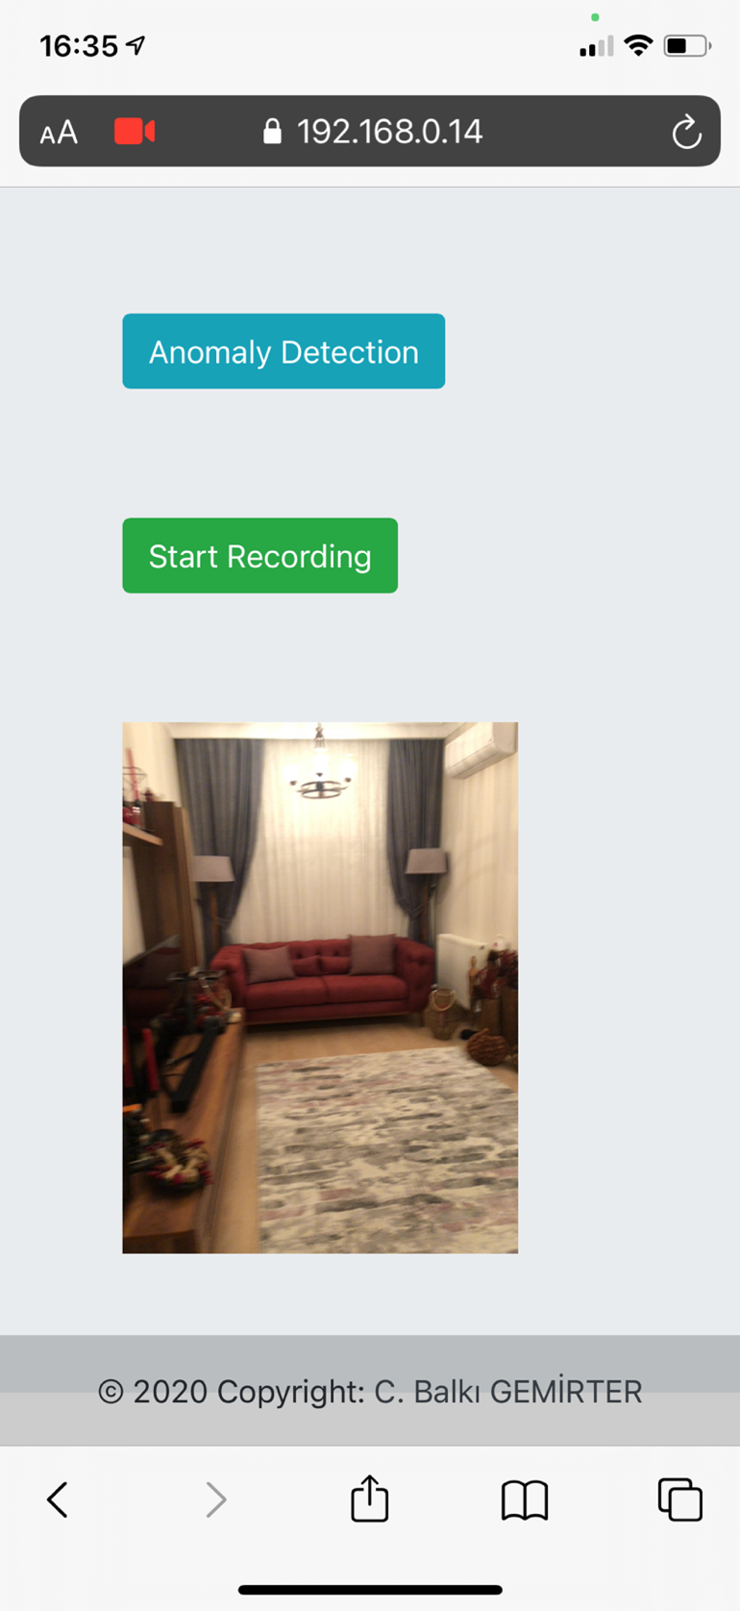

Figure . Web Interface of the project.

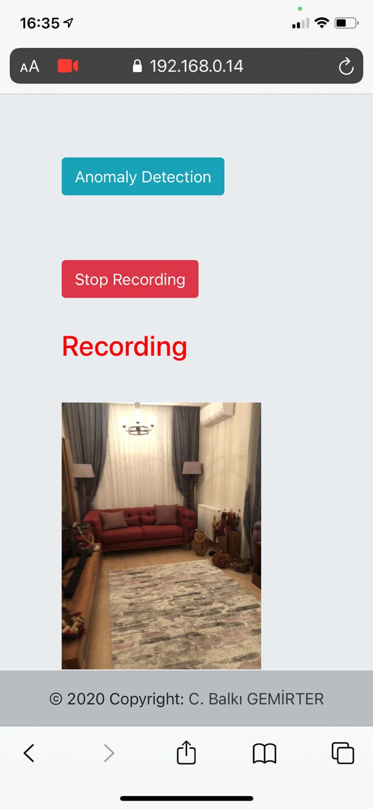

Figure 2. Recording scenario.

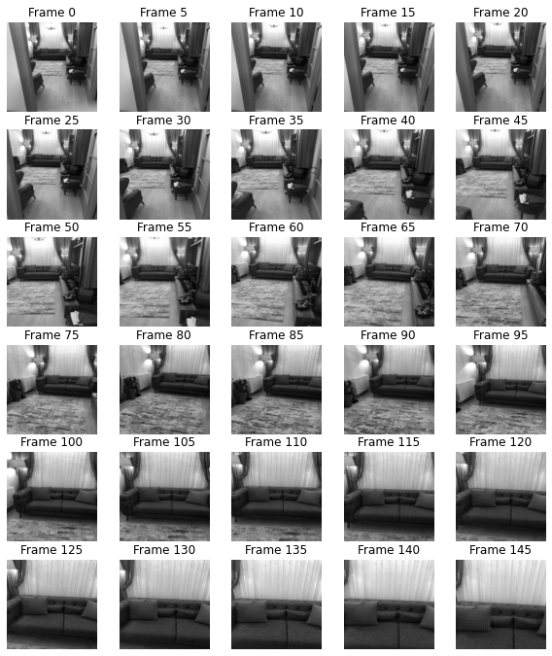

Figure 3. Some sample frames of a recording session.

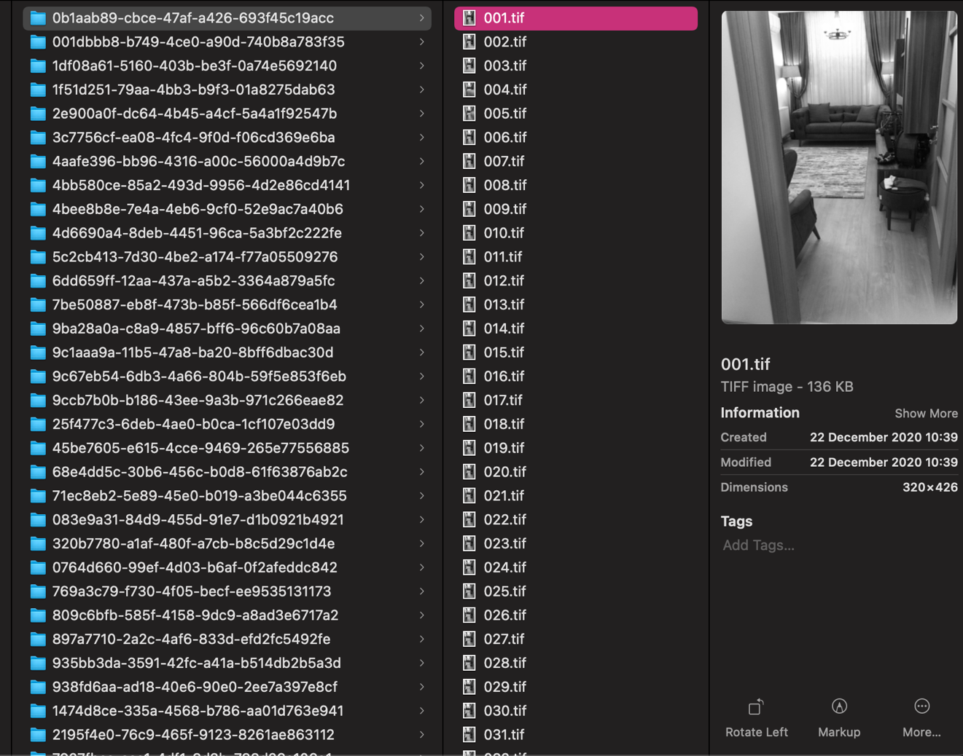

Figure 4. File system view of a recording session.

## Training Module

Several different methods had been applied to find the best approach for the application that works well in real-time and has accurate outputs for obstacle detection.

### Anomaly Detection in Videos

This method is used to detect unusual events in surveillance cameras. With LSTM Convolutional Neural Network Autoencoders, it detects abnormal events and objects in a video. For every frame, training modules get *frame t* with the previous ten frames as input and make a prediction (Figure 5 and Figure 6). Comparing the real *frame t* with the predicted frame, the algorithm calculates a reconstruction cost result and plots the distances. If the reconstruction cost is greater than the threshold, the frame is marked as an abnormal frame.

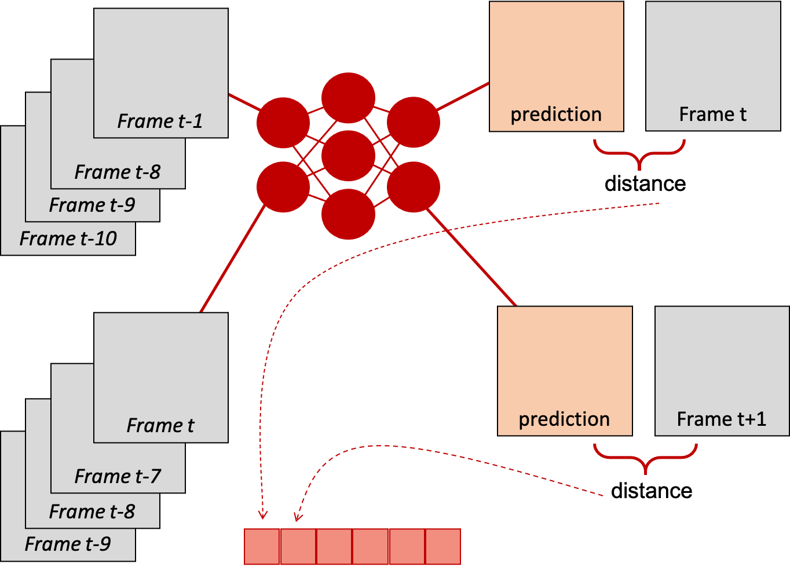

Figure 5. Anomaly detection in videos.

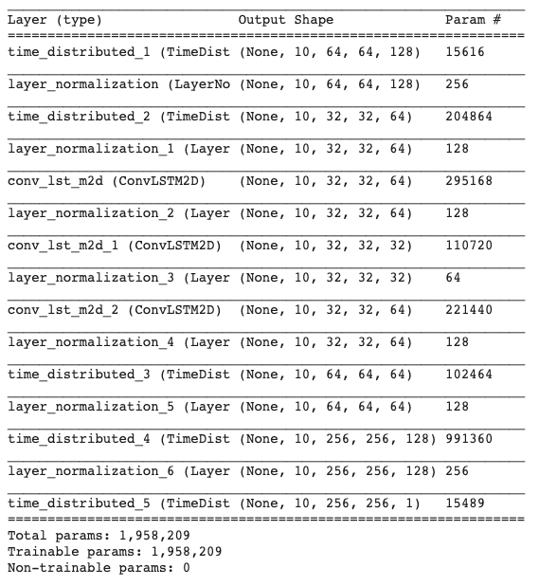

Figure 6. LSTM CNN Autoencoder model.

Figure 7 shows the distance graph of a video that has an obstacle. After normalizing the reconstruction cost, (1 - RC) gives the regularity score of each frame. At frame 40, the camera is very close to the obstacle. After frame 100, the user passes near the object, and the graph starts an upward movement.

Evaluation time of a video that has 200 frames takes nearly three minutes on a GPU. Hence predicting all the frames process is slow; rather than a real-time application, the method is only applicable for offline video predictions.

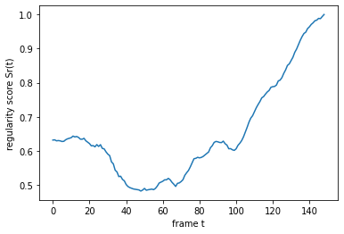

Figure 7. Regularity score of a video.

### Video Frame Prediction

This method is used to predict the next few frames of a video given the previous frames (Figure 8). The video frame predictor can learn the probability distribution of the frames with previously seen video frames. The model has a Sequential layer, 2D Convolutional Neural Network & LSTM layers, and a 3D Convolutional Neural Network layer (Figure 9). ConvLSTM2D are classic LSTM layers that have 2-dimensional convolutional transformations to interpret 2D images and the last Conv3D layer extracts critical visual features.

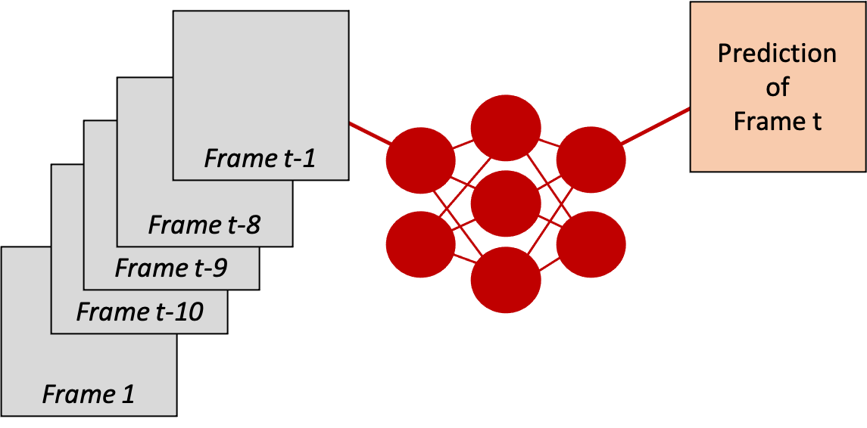

Figure 8. Next frame prediction.

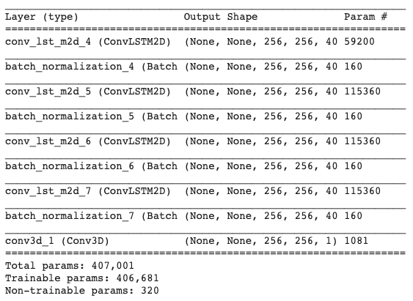

Figure 9. Video frame prediction model.

For obstacle detection, the method is not applicable. The user is walking through the obstacle, and the input frames of the Neural Network already have obstacle objects (Figure 10). Hence, the predicted next frame has obstacle object parts, and this methodology is not useful for obstacle detection in the video.

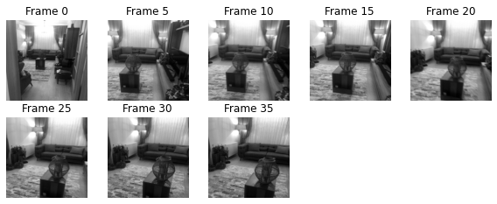

Figure 10. Neural network input frames.

### Image Classification

Image classification is the task of classifying an image from a fixed set of categories. Many other computer vision challenges such as object detection and segmentation can be reduced to image classification. In the project, videos are labeled as an obstacle with abnormal objects on the road or normal. Every frame of each video with the label is the inputs of the training (Figure 11). The model has several 2D Convolutional and 2D Max Pooling layers. In the end, there is a sigmoid binary classifier (Figure 12). The result has two possible outputs; the video may have an obstacle or not.

When compared with previous video-based approaches, image classification has better speed and applicable for real-time prediction applications. During training, the model learns the critical features of obstacles that are present in the training set. On prediction, the model only gets one frame rather than a full clip and returns 0 or 1 whether the frame has an obstacle or not. Data augmentation techniques may be applied to the image dataset to enhance the success of the training, such as shifting, adding brightness, or rotating the image. Some rotating examples are present in Figure 13.

After all investigations, Image Classification approach will be used for deep learning solution of abnormality detection in the real-time video.

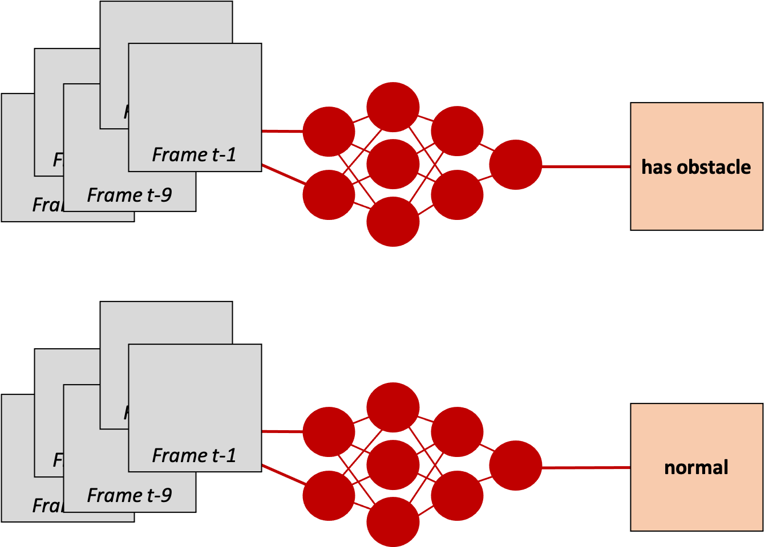

Figure . Binary image classification.

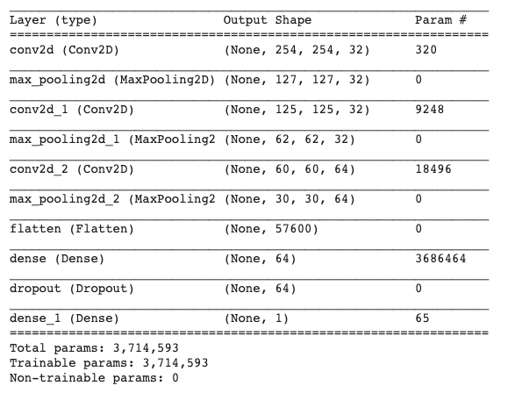

Figure . Image classification model.

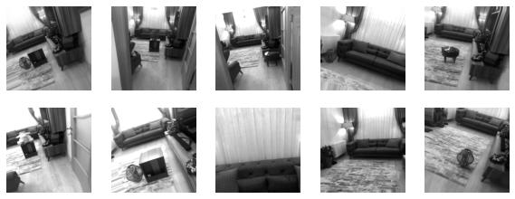

Figure 13. Data augmentation examples.

# IMPLEMENTATION

## Recording Module

Python Flask is used in the recording module as a Web server. The server serves on HTTPS because WebRTC technology forces only SSL connections for media operations. The homepage of the application is index.html which has all HTML codes of the application.

*import* os  
*from* flask *import* Flask, Response, request  
*from* PIL *import* Image  
*from* predict *import* get_model, evaluate  
  
app = Flask(__name__)  
files_folder = os.path.join(os.getcwd(), "files")  
model = get_model()

@app.after_request  
*def* after_request(response):  
 response.headers.add('Access-Control-Allow-Origin', '*')  
 response.headers.add('Access-Control-Allow-Headers', 'Content-Type,Authorization')  
 response.headers.add('Access-Control-Allow-Methods', 'GET,POST')  
 *return* response

@app.route('/')  
*def* index():  
 *return* Response(*open*('static/index.html').read(), mimetype="text/html")

……

*if* __name__ == '__main__':  
 app.run(host="192.168.0.14", port=9000, debug=*False*, ssl_context=('ssl/server.crt', 'ssl/server.key'))

Figure . Recording module implementation - Part 1.

When the user clicks "Start Recording", a restful service request call is done to **recordingImage** method for every 50 milliseconds. The method gets the *image form data*, the video session's unique ID (*UUID*), and the frame id in the session (*count*). With these parameters, the image is stored in the files system: in the UUID directory with the name <count.tif>. Before saving, the image is changed to monochrome mode as a black and white image (Figure 15).

@app.route('/recordingImage', methods=['POST'])  
*def* image():  
 image_file = request.files['image']  
 uuid = request.form.get('uuid')  
 count = request.form.get('count')  
 image_object = Image.open(image_file).convert('L')  
 images_folder = os.path.join(files_folder, uuid)  
 *if not* os.path.exists(images_folder):  
 *try*:  
 os.mkdir(images_folder)  
 *except*:  
 *print*("Ignore")  
  
 file_name = os.path.join(images_folder, *str*(count) + ".tif")  
 image_object.save(file_name)  
 *return* "save"

Figure . Saving sample files.

## Preprocess Module

On the recording module, all frames are stored in their video session ID folder. For image classification, the frames should be in their category label folders as **normal** or **obstacle**. Preprocess module moves frame tif files to the relevant label folder and renames them by a unique identifier. In Figure 16, the *"Tree view of ./files"* section shows the folder hierarchy before preprocessing, and the *"Tree view of ./regerated_files"* section shows after preprocessing.

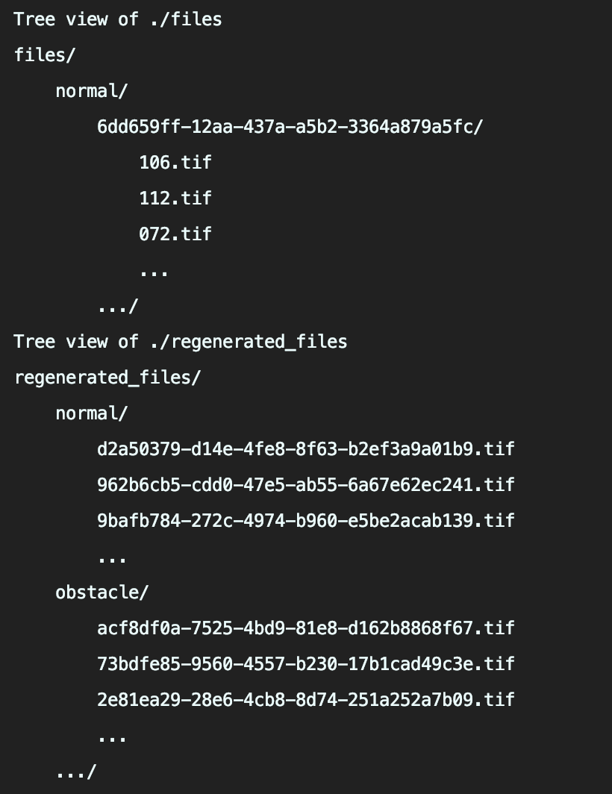

Figure . Preprocessing module.

Preprocess module execution time is large because moving and renaming files are expensive.

Adding parallelism has a positive effect on the results. Files are split into several processes equally using a slider block approach. Total file count is divided by thread count and distributed to cores as seen on Figure 18.

*def* preprocess_images():  
 data = []  
 *for* f *in sorted*(os.listdir(Config.DATASET_PATH)):  
 directory_path = os.path.join(Config.DATASET_PATH, f)  
 *if* os.path.isdir(directory_path):  
 class_name = f  
 *for* v *in sorted*(os.listdir(directory_path)):  
 sub_directory_path = os.path.join(directory_path, v)  
 *for* c *in sorted*(os.listdir(sub_directory_path)):  
 data.append([sub_directory_path, c, class_name])  
  
 df = pd.DataFrame(data=data, columns=['directory_path', 'file_name', 'label'])  
 sample_count = *len*(df)  
 slider = *int*(sample_count / Config.THREAD_COUNT)  
  
 sliders = []  
 *for* i *in range*(Config.THREAD_COUNT):  
 sliders.append(i * slider)  
 sliders.append(sample_count)  
  
 *print*("Sliders", sliders)  
  
 df = df.iloc[np.random.permutation(*len*(df))]  
  
 dfs = []  
 *for* i *in range*(Config.THREAD_COUNT):  
 dfs.append(df.iloc[sliders[i]:sliders[i + 1] - 1])  
  
 *for* i *in range*(Config.THREAD_COUNT):  
 *print*('registering process %d' % i)  
 proc = mp.Process(target=preprocess_image, args=(dfs[i],))  
 processes[i] = proc  
 proc.start()  
  
 *while* (*True*):  
 finished_count = 0  
 *for* id *in* processes.keys():  
 *if not* processes[id].is_alive():  
 finished_count = finished_count + 1  
  
 *if* finished_count == Config.THREAD_COUNT:  
 *break  
 else*:  
 time.sleep(5)

Figure . Preprocessing images.

1 thread

Execution time: 906.1935679912567 seconds.

2 threads

Execution time: 535.13072681427 seconds.

4 threads

Execution time: 305.7009949684143 seconds.

8 threads

Execution time: 195.29807686805725 seconds.

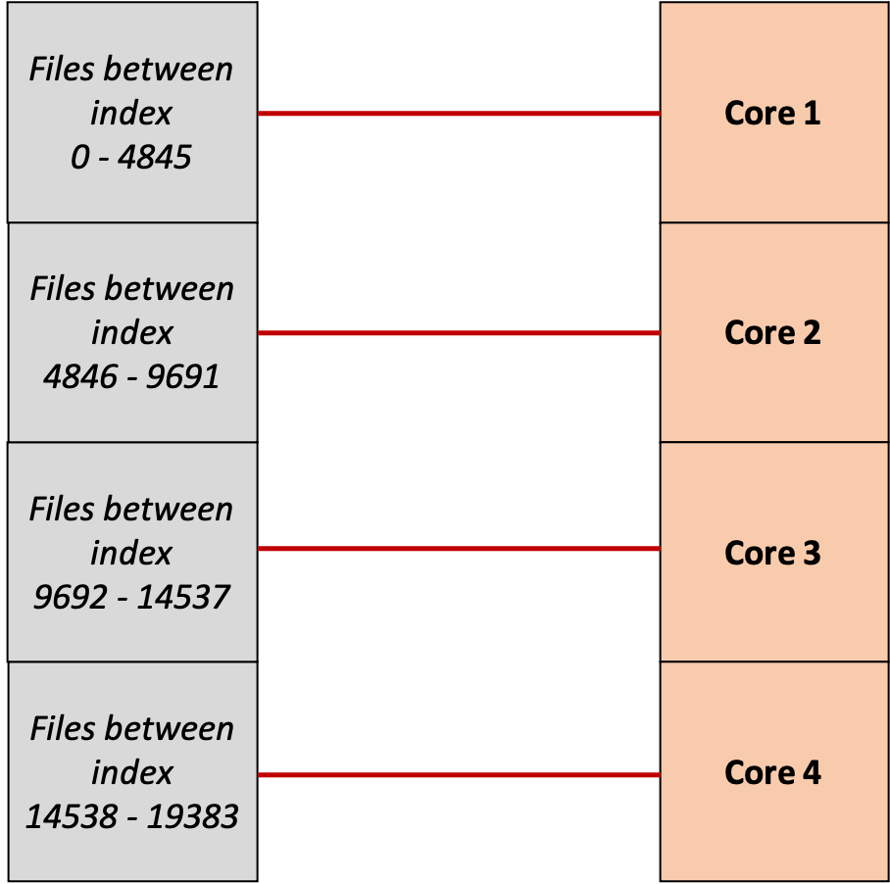

Figure . Multiprocessing on preprocessing step.

## Training Module

### Image Preprocessıng

Before start training, data augmentation is applied to the images (Figure 19). ImageDataGenerator is a built-in function of Keras library. In data augmentation, the images are rescaled at 1/255. ‘Shear’ means that the image will be distorted along an axis, mostly to create or rectify the perception angles. It's usually used to augment images so that computers can see how humans see things from different angles. 30-degree rotation is used. Points outside the boundaries of the input are filled according to the given mode: nearest. The brightness shift value is between 0.4 and 1.5.

Training data is read from the given folder and loaded to ImageDataGenerator. The target size of the images is 256 x 256, and the color mode is grayscale. In training, image files are X values, and folder names are Y values. There are only 2 class labels as normal and obstacle, so class_mode is set as ‘binary’. For a better training result, shuffling is enabled, else the files are ordered alphanumerically. Default batch_size ise 32 and in experiment, different batch_sizes are trained.

The **train_generator** yielding tuples of (x, y) where x is a numpy array containing a batch of images with shape (batch_size, *target_size, channels) and y is a numpy array of corresponding labels.

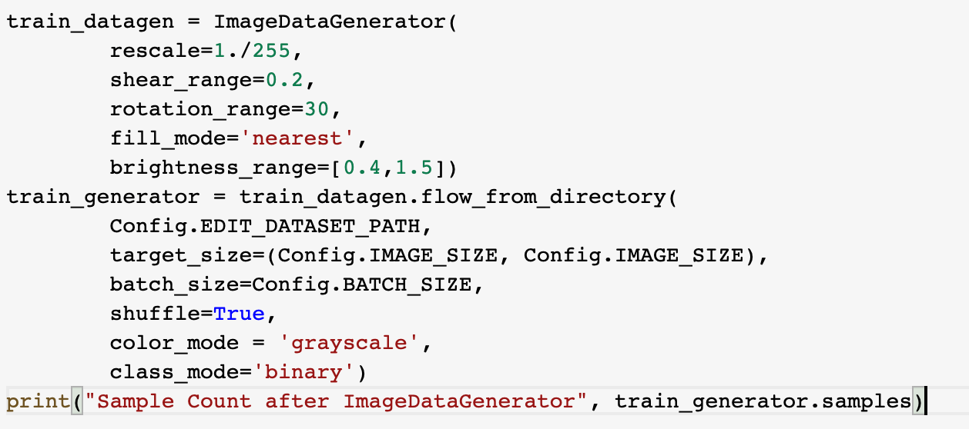

Figure . Data augmentation configurations.

The training data has the following class names and sample counts:

* Class Name: normal , Samples Count: 10636
* Class Name: obstacle , Samples Count: 8748
* Total Samples Count: 19384

Some samples of the classes are shown in Figure 20 and Figure 21.



Figure . Samples of 'normal' class.



Figure . Samples of 'obstacle' class.

### Training

The training code is attached in Figure 22. In training, input shape is the size of an image, 256 x 256 x 1. Because grayscale is used, only one channel is enough. There are 3 CNN and Max Pooling layers with kernel size = 3 and pool size = 2. Relu is used as the activation function. The output layer of the system is a sigmoid activated dense layer. Adam optimizer is used, and the evaluation metric is accuracy. Hence there are only two classes for image classification; the loss function is binary cross-entropy. After fitting the data to the model and training, the algorithm plots every epoch's loss and accuracy. Epoch size is set to 10.

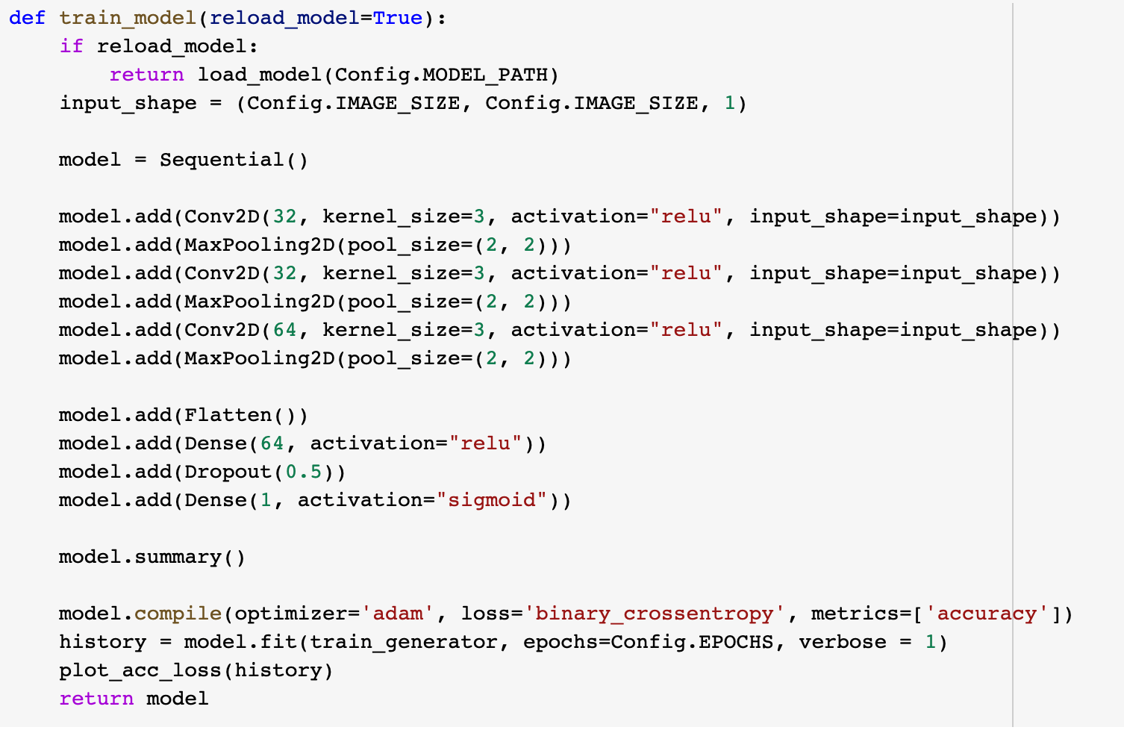

Figure . Model configuration.

Model: "sequential"

_________________________________________________________________

Layer (type) Output Shape Param #

=================================================================

conv2d (Conv2D) (None, 254, 254, 32) 320

_________________________________________________________________

max_pooling2d (MaxPooling2D) (None, 127, 127, 32) 0

_________________________________________________________________

conv2d_1 (Conv2D) (None, 125, 125, 32) 9248

_________________________________________________________________

max_pooling2d_1 (MaxPooling2 (None, 62, 62, 32) 0

_________________________________________________________________

conv2d_2 (Conv2D) (None, 60, 60, 64) 18496

_________________________________________________________________

max_pooling2d_2 (MaxPooling2 (None, 30, 30, 64) 0

_________________________________________________________________

flatten (Flatten) (None, 57600) 0

_________________________________________________________________

dense (Dense) (None, 64) 3686464

_________________________________________________________________

dropout (Dropout) (None, 64) 0

_________________________________________________________________

dense_1 (Dense) (None, 1) 65

=================================================================

Total params: 3,714,593

Trainable params: 3,714,593

Non-trainable params: 0

### Results

The training results of different batch sizes are listed below. In the experiments it is seen that, 3 epochs are enough for an accurate system. The training had been done on Google Colab environment with Tesle V-100 GPU and the details are listed in Figure 23.

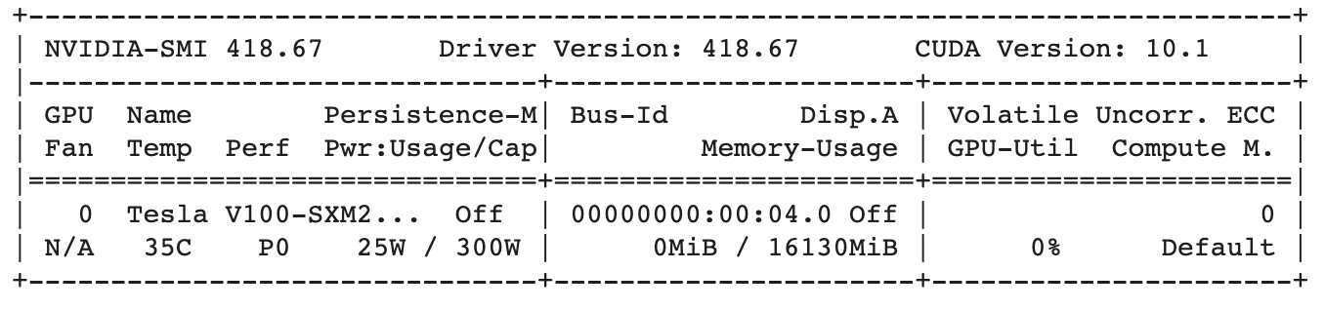

Figure . GPU details.

**BATCH_SIZE = 32**

ImageDataGenerator Execution time: 1.2463414669036865 seconds.

_________________________________________________________________

Epoch 1/10

607/607 [==============================] - 220s 361ms/step - loss: 0.2506 - accuracy: 0.9010

Epoch 2/10

607/607 [==============================] - 217s 358ms/step - loss: 0.0470 - accuracy: 0.9872

Epoch 3/10

607/607 [==============================] - 216s 356ms/step - loss: 0.0367 - accuracy: 0.9879

Epoch 4/10

607/607 [==============================] - 216s 356ms/step - loss: 0.0216 - accuracy: 0.9941

Epoch 5/10

607/607 [==============================] - 218s 358ms/step - loss: 0.0417 - accuracy: 0.9883

Epoch 6/10

607/607 [==============================] - 217s 357ms/step - loss: 0.0321 - accuracy: 0.9917

Epoch 7/10

607/607 [==============================] - 217s 356ms/step - loss: 0.0216 - accuracy: 0.9942

Epoch 8/10

607/607 [==============================] - 217s 357ms/step - loss: 0.0269 - accuracy: 0.9926

Epoch 9/10

607/607 [==============================] - 217s 357ms/step - loss: 0.0198 - accuracy: 0.9940

Epoch 10/10

607/607 [==============================] - 217s 357ms/step - loss: 0.0186 - accuracy: 0.9942

Train Execution time: 2172.581623315811 seconds.

Model is ready.

Model saved : /content/drive/MyDrive/AnomalyDetectionInVideos/model.hdf5

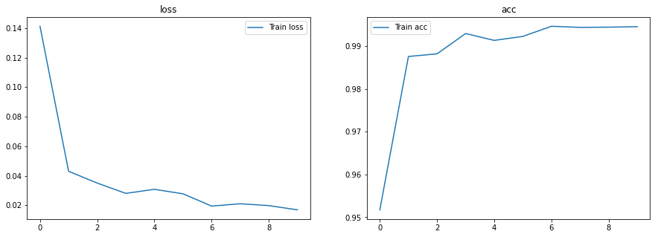

**BATCH_SIZE = 64**

ImageDataGenerator Execution time: 1.4425477981567383 seconds.

_________________________________________________________________

Epoch 1/10

304/304 [==============================] - 214s 700ms/step - loss: 0.2966 - accuracy: 0.8719

Epoch 2/10

304/304 [==============================] - 213s 698ms/step - loss: 0.0718 - accuracy: 0.9805

Epoch 3/10

304/304 [==============================] - 212s 696ms/step - loss: 0.0407 - accuracy: 0.9897

Epoch 4/10

304/304 [==============================] - 212s 695ms/step - loss: 0.0303 - accuracy: 0.9901

Epoch 5/10

304/304 [==============================] - 211s 692ms/step - loss: 0.0318 - accuracy: 0.9913

Epoch 6/10

304/304 [==============================] - 210s 690ms/step - loss: 0.0254 - accuracy: 0.9927

Epoch 7/10

304/304 [==============================] - 211s 692ms/step - loss: 0.0200 - accuracy: 0.9942

Epoch 8/10

304/304 [==============================] - 210s 691ms/step - loss: 0.0191 - accuracy: 0.9933

Epoch 9/10

304/304 [==============================] - 210s 689ms/step - loss: 0.0203 - accuracy: 0.9945

Epoch 10/10

304/304 [==============================] - 210s 689ms/step - loss: 0.0251 - accuracy: 0.9926

Train Execution time: 2112.119071483612 seconds.

Model is ready.

Model saved : /content/drive/MyDrive/AnomalyDetectionInVideos/model.hdf5

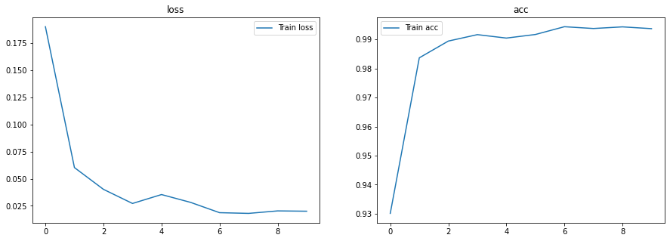

**BATCH_SIZE = 128**

ImageDataGenerator Execution time: 1.9580705165863037 seconds.

_________________________________________________________________

Epoch 1/10

152/152 [==============================] - 211s 1s/step - loss: 0.3580 - accuracy: 0.8301

Epoch 2/10

152/152 [==============================] - 208s 1s/step - loss: 0.0864 - accuracy: 0.9764

Epoch 3/10

152/152 [==============================] - 207s 1s/step - loss: 0.0467 - accuracy: 0.9870

Epoch 4/10

152/152 [==============================] - 206s 1s/step - loss: 0.0361 - accuracy: 0.9897

Epoch 5/10

152/152 [==============================] - 206s 1s/step - loss: 0.0308 - accuracy: 0.9922

Epoch 6/10

152/152 [==============================] - 205s 1s/step - loss: 0.0228 - accuracy: 0.9928

Epoch 7/10

152/152 [==============================] - 205s 1s/step - loss: 0.0221 - accuracy: 0.9933

Epoch 8/10

152/152 [==============================] - 205s 1s/step - loss: 0.0179 - accuracy: 0.9949

Epoch 9/10

152/152 [==============================] - 205s 1s/step - loss: 0.0194 - accuracy: 0.9945

Epoch 10/10

152/152 [==============================] - 205s 1s/step - loss: 0.0192 - accuracy: 0.9942

Train Execution time: 2065.073174238205 seconds.

Model is ready.

Model saved : /content/drive/MyDrive/AnomalyDetectionInVideos/model.hdf5

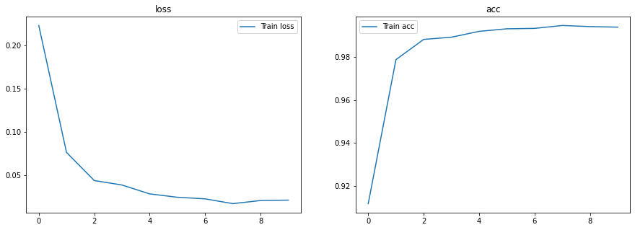

**BATCH_SIZE = 256**

ImageDataGenerator Execution time: 2.72823166847229 seconds.

_________________________________________________________________

Epoch 1/10

76/76 [==============================] - 216s 3s/step - loss: 0.4068 - accuracy: 0.8089

Epoch 2/10

76/76 [==============================] - 214s 3s/step - loss: 0.0982 - accuracy: 0.9719

Epoch 3/10

76/76 [==============================] - 214s 3s/step - loss: 0.0647 - accuracy: 0.9816

Epoch 4/10

76/76 [==============================] - 213s 3s/step - loss: 0.0414 - accuracy: 0.9894

Epoch 5/10

76/76 [==============================] - 213s 3s/step - loss: 0.0353 - accuracy: 0.9901

Epoch 6/10

76/76 [==============================] - 212s 3s/step - loss: 0.0273 - accuracy: 0.9929

Epoch 7/10

76/76 [==============================] - 211s 3s/step - loss: 0.0254 - accuracy: 0.9924

Epoch 8/10

76/76 [==============================] - 212s 3s/step - loss: 0.0219 - accuracy: 0.9935

Epoch 9/10

76/76 [==============================] - 211s 3s/step - loss: 0.0191 - accuracy: 0.9947

Epoch 10/10

76/76 [==============================] - 210s 3s/step - loss: 0.0252 - accuracy: 0.9930

Train Execution time: 2127.3730380535126 seconds.

Model is ready.

Model saved : /content/drive/MyDrive/AnomalyDetectionInVideos/model.hdf5

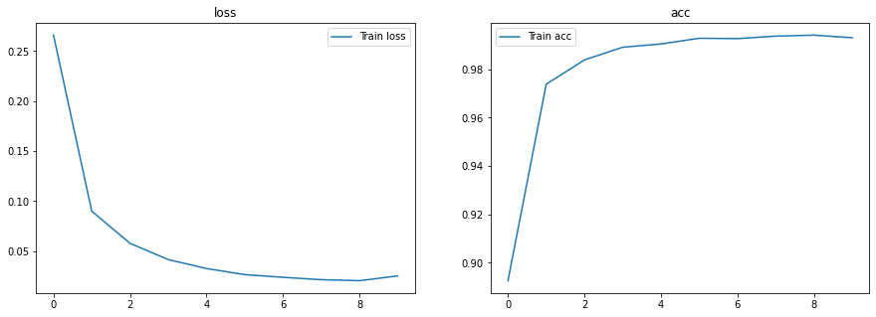

## CPU vs GPU

Two trainings with the same configurations are repeated in CPU and GPU environments. The environment in CPU has 4 cores with the details in Figure 24. GPU is 7 times faster than CPU. The execution times are:

With CPU:

Train Execution time: **14235.833163022995** seconds.

With GPU:

Train Execution time: **2127.3730380535126** seconds.

**CPU Logs:**

Epoch 1/10

76/76 [==============================] - 8244s 108s/step - loss: 0.5646 - accuracy: 0.7003

Epoch 2/10

76/76 [==============================] - 672s 9s/step - loss: 0.1966 - accuracy: 0.9351

Epoch 3/10

76/76 [==============================] - 668s 9s/step - loss: 0.1230 - accuracy: 0.9671

Epoch 4/10

76/76 [==============================] - 667s 9s/step - loss: 0.0766 - accuracy: 0.9790

Epoch 5/10

76/76 [==============================] - 668s 9s/step - loss: 0.0595 - accuracy: 0.9842

Epoch 6/10

76/76 [==============================] - 667s 9s/step - loss: 0.0514 - accuracy: 0.9843

Epoch 7/10

76/76 [==============================] - 663s 9s/step - loss: 0.0469 - accuracy: 0.9880

Epoch 8/10

76/76 [==============================] - 663s 9s/step - loss: 0.0429 - accuracy: 0.9880

Epoch 9/10

76/76 [==============================] - 661s 9s/step - loss: 0.0494 - accuracy: 0.9867

Epoch 10/10

76/76 [==============================] - 661s 9s/step - loss: 0.0354 - accuracy: 0.9888

Train Execution time: 14235.833163022995 seconds.

Model is ready.

Model saved : /content/drive/MyDrive/AnomalyDetectionInVideos/model.hdf5

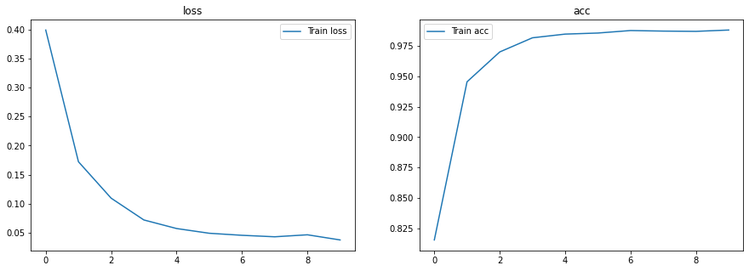

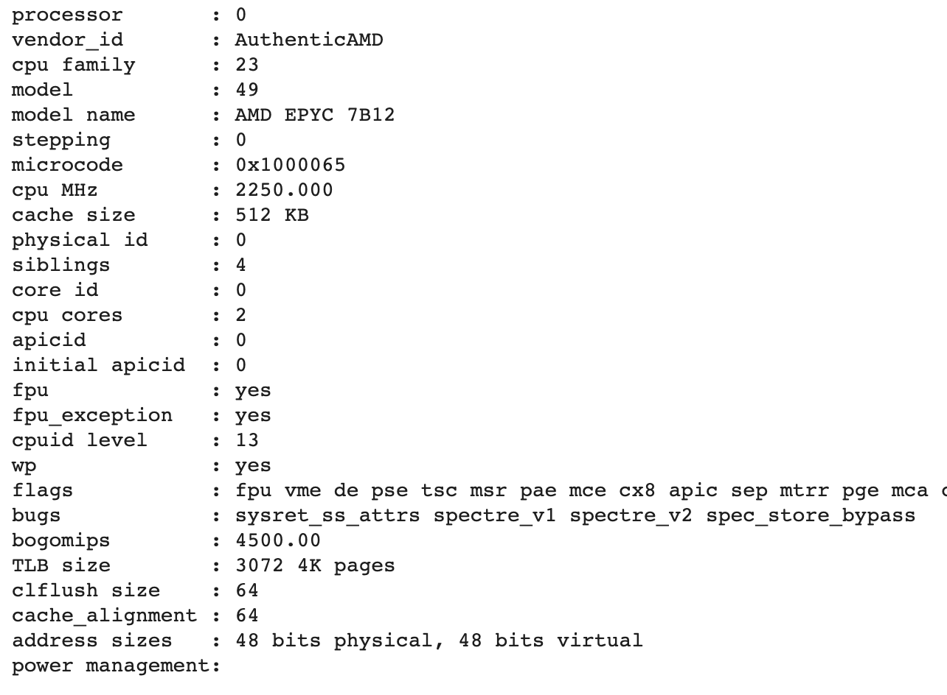

Figure . CPU configurations.

## Sıngle Thread VS Multı Thread

Adding parallelism has a positive effect on the training execution times. Because of the OutOfMemory problem, it is impossible to train the final CNN model in a multiprocess environment, and for comparison, a smaller model is built.

Model: "sequential"

_________________________________________________________________

Layer (type) Output Shape Param #

=================================================================

conv2d (Conv2D) (None, 254, 254, 32) 320

_________________________________________________________________

max_pooling2d (MaxPooling2D) (None, 127, 127, 32) 0

_________________________________________________________________

flatten (Flatten) (None, 516128) 0

_________________________________________________________________

dense (Dense) (None, 64) 33032256

_________________________________________________________________

dropout (Dropout) (None, 64) 0

_________________________________________________________________

dense_1 (Dense) (None, 1) 65

=================================================================

Total params: 33,032,641

Trainable params: 33,032,641

Non-trainable params: 0

After shuffling, train data files are split into several processes equally using a slider block approach. Total file count is divided by thread count and distributed to cores as seen on Figure 25.

At the end of the training, there are n trained model files, where n is the process count. Keras has built-in functions to use multiple models to merge for prediction.

Multiprocessed training operation has better execution time compared with single-process. But, the accuracies of smaller & multiprocess models are worse because of smaller train/validation data sets after splitting. In AI projects, it is advised to use larger datasets and a single model for better results.

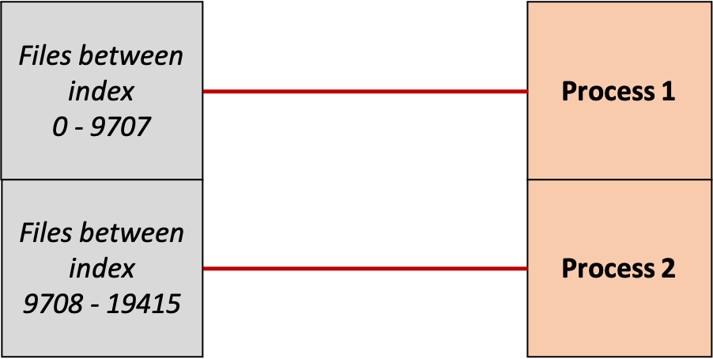

Figure . Multiprocessing on training.

Execution logs and accuracies are:

1 thread:

registering process 0

Found 19416 validated image filenames belonging to 2 classes.

Sample Count after ImageDataGenerator 19416

I will start process 0

Data is ready for process 0

Epoch 1/10

76/76 [==============================] - 379s 5s/step - loss: 3.0813 - accuracy: 0.7125

Epoch 2/10

76/76 [==============================] - 373s 5s/step - loss: 0.2544 - accuracy: 0.9055

Epoch 3/10

76/76 [==============================] - 363s 5s/step - loss: 0.1867 - accuracy: 0.9379

Epoch 4/10

76/76 [==============================] - 360s 5s/step - loss: 0.1542 - accuracy: 0.9479

Epoch 5/10

76/76 [==============================] - 363s 5s/step - loss: 0.1431 - accuracy: 0.9566

Epoch 6/10

76/76 [==============================] - 360s 5s/step - loss: 0.1199 - accuracy: 0.9625

Epoch 7/10

76/76 [==============================] - 356s 5s/step - loss: 0.1186 - accuracy: 0.9619

Epoch 8/10

76/76 [==============================] - 356s 5s/step - loss: 0.1131 - accuracy: 0.9636

Epoch 9/10

76/76 [==============================] - 357s 5s/step - loss: 0.0984 - accuracy: 0.9681

Epoch 10/10

76/76 [==============================] - 368s 5s/step - loss: 0.0912 - accuracy: 0.9679

Model is ready for process 0

Model saved : /content/drive/MyDrive/AnomalyDetectionInVideos/model_0.hdf5

I've finished process 0

Train Execution time: 3648.6774666309357 seconds.

2 threads:

registering process 0

registering process 1

Found 9707 validated image filenames belonging to 2 classes.

Found 9708 validated image filenames belonging to 2 classes.

Sample Count after ImageDataGenerator 9707

I will start process 0

Sample Count after ImageDataGenerator 9708

I will start process 1

Data is ready for process 0

Data is ready for process 1

Epoch 1/10

Epoch 1/10

38/38 [==============================] - 337s 9s/step - loss: 3.9491 - accuracy: 0.6417

Epoch 2/10

38/38 [==============================] - 338s 9s/step - loss: 4.1070 - accuracy: 0.6783

Epoch 2/10

38/38 [==============================] - 340s 9s/step - loss: 0.3521 - accuracy: 0.8481

Epoch 3/10

38/38 [==============================] - 344s 9s/step - loss: 0.3656 - accuracy: 0.8470

Epoch 3/10

38/38 [==============================] - 336s 9s/step - loss: 0.3091 - accuracy: 0.8745

Epoch 4/10

38/38 [==============================] - 341s 9s/step - loss: 0.3153 - accuracy: 0.8812

Epoch 4/10

38/38 [==============================] - 332s 9s/step - loss: 0.2819 - accuracy: 0.9009

Epoch 5/10

38/38 [==============================] - 339s 9s/step - loss: 0.2731 - accuracy: 0.9061

Epoch 5/10

38/38 [==============================] - 332s 9s/step - loss: 0.2355 - accuracy: 0.9166

Epoch 6/10

38/38 [==============================] - 339s 9s/step - loss: 0.2527 - accuracy: 0.9145

Epoch 6/10

38/38 [==============================] - 336s 9s/step - loss: 0.2153 - accuracy: 0.9231

Epoch 7/10

38/38 [==============================] - 343s 9s/step - loss: 0.2521 - accuracy: 0.9173

Epoch 7/10

38/38 [==============================] - 341s 9s/step - loss: 0.1882 - accuracy: 0.9329

Epoch 8/10

38/38 [==============================] - 345s 9s/step - loss: 0.2526 - accuracy: 0.9150

Epoch 8/10

38/38 [==============================] - 348s 9s/step - loss: 0.1903 - accuracy: 0.9278

Epoch 9/10

38/38 [==============================] - 354s 9s/step - loss: 0.2328 - accuracy: 0.9231

Epoch 9/10

38/38 [==============================] - 346s 9s/step - loss: 0.1771 - accuracy: 0.9364

Epoch 10/10

38/38 [==============================] - 351s 9s/step - loss: 0.2004 - accuracy: 0.9403

Epoch 10/10

38/38 [==============================] - 342s 9s/step - loss: 0.1615 - accuracy: 0.9505

Model is ready for process 0

Model saved : /content/drive/MyDrive/AnomalyDetectionInVideos/model_0.hdf5

I've finished process 0

38/38 [==============================] - 326s 8s/step - loss: 0.2112 - accuracy: 0.9337

Model is ready for process 1

Model saved : /content/drive/MyDrive/AnomalyDetectionInVideos/model_1.hdf5

I've finished process 1

Train Execution time: 3428.498650789261 seconds.

## Predıctıon Module

After training, the trained model weight file is put in the Project for real-time predictions. When user clicks “Anomaly Detection” button on the application web pages, as done on recording module, a restful service request call is done to **anomalyDetection** method for every 100 milliseconds. The method gets the *image form data* and the image is changed to monochrome mode as a black and white image.

@app.route('/anomalyDetection', methods=['POST'])  
*def* anomaly_detection():  
 image_file = request.files['image']  
 image_object = Image.open(image_file).convert('L')  
 *return* evaluate(model, image_object)

Figure . Anomaly Detection method.

After the image is converted a numpy array and reshaped as model input, the model returns 0 or 1 which indicated whether this is a normal frame or includes an obstacle (Figure 27). If the response is “1”, the main.js function shows an “Anomality Detected !!!” alert in the web page, else the alert is hidden (Figure 28).

*import* os  
*import* numpy *as* np  
*from* keras.models *import* load_model  
  
  
*class* Config:  
 MODEL_PATH = os.path.join("model", "model.hdf5")  
 IMAGE_SIZE = 256  
  
  
*def* get_test_data(img):  
 img = img.resize((Config.IMAGE_SIZE, Config.IMAGE_SIZE))  
 img = np.array(img, dtype=np.float32) / 256.0  
 img = np.reshape(img, img.shape + (1,))  
 *return* img  
  
  
*def* get_model():  
 *return* load_model(Config.MODEL_PATH)  
  
  
*def* evaluate(model, img):  
 frame = get_test_data(img)  
 frame = np.array(frame)  
 frame = np.reshape(frame, (1,) + frame.shape)  
 prediction = model.predict(frame)  
 *return str*(*int*(prediction[0][0]))

Figure . Prediction method.

*function doAnomalyDetection*(file) {  
 *//Set options as form data  
 let* formdata = *new* FormData();  
 formdata.append("image", file);  
 formdata.append("uuid", uuid);  
  
 *let* xhr = *new* XMLHttpRequest();  
 xhr.open('POST', apiServer + "/anomalyDetection", *true*);  
 xhr.onload = *function* () {  
 *if* (*this*.status === 200) {  
 console.info(*this*.response)  
 *if* (!anomalyDetecting) {  
 $("#abnormal").hide();  
 *return* }  
  
 *if* ("1" === *this*.response) {  
 $("#abnormal").show();  
 }  
 *else* {  
 $("#abnormal").hide();  
 }  
 }  
 *else* {  
 console.error(xhr);  
 }  
 };  
 xhr.send(formdata);  
}

Figure . Show or hide the alert.

# Tensorflow and GPU Archıtecture

Tensorflow is an open source software library developed by Google Brain Team. Tensorflow is used for ML numerical computations for data flows. In the graph, the nodes are the mathematical computations and the edges represents multidimensional numerical data arrays which are also called as tensors.

Tensorflow supports CPU, GPU and TPU hardwares. Tensorflow has a Master&Worker architecture where workers are the CPU/GPU instances. Workers gets requests from master and generates subgraphs for kernels. The kernels work in parallel on local devices when multi CPU cores or GPUs are available.

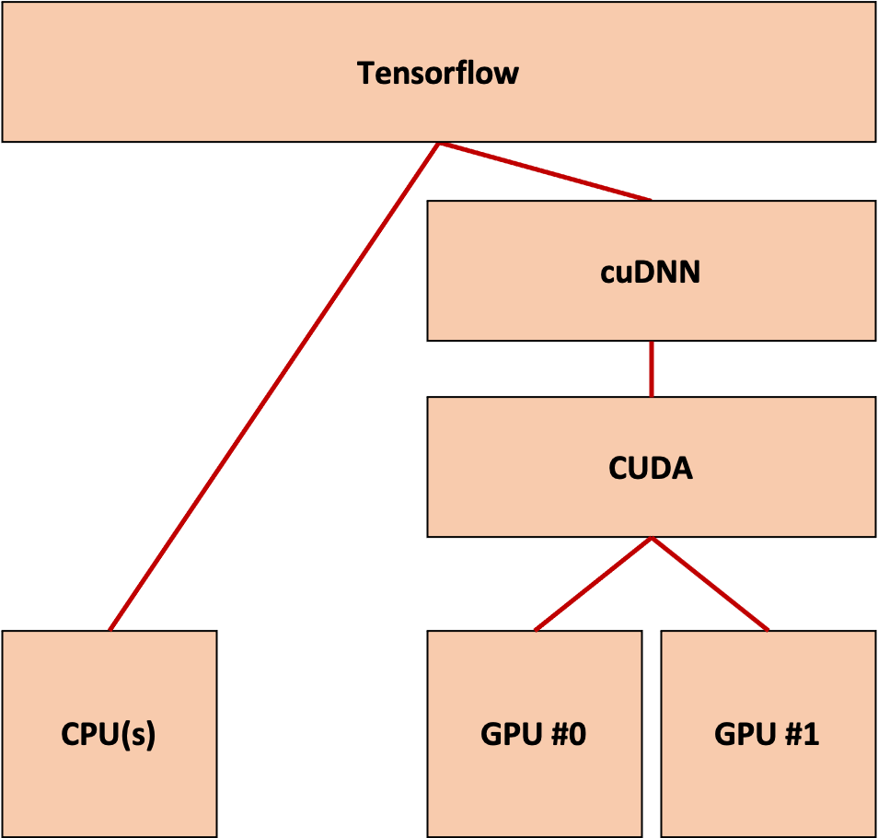

Figure . Tensorflow archirecture.

Using COST model, tensorflow estimates the input & output sizes and computation times using greedy heuristic decision models. Tensorflow first simulates the whole graph and determines feasible devices for execution. Each device has two thread pools for scheduling operations: inter-op and intra-op thread pools. There are cross-device communications between devices. Using cudaMemcpyAsync() API, CPU and GPU devices transfers data. When two GPUs share data, P2P DMA is used to avoid CPU overheads. GPUs on different workers uses RDMA to share data.

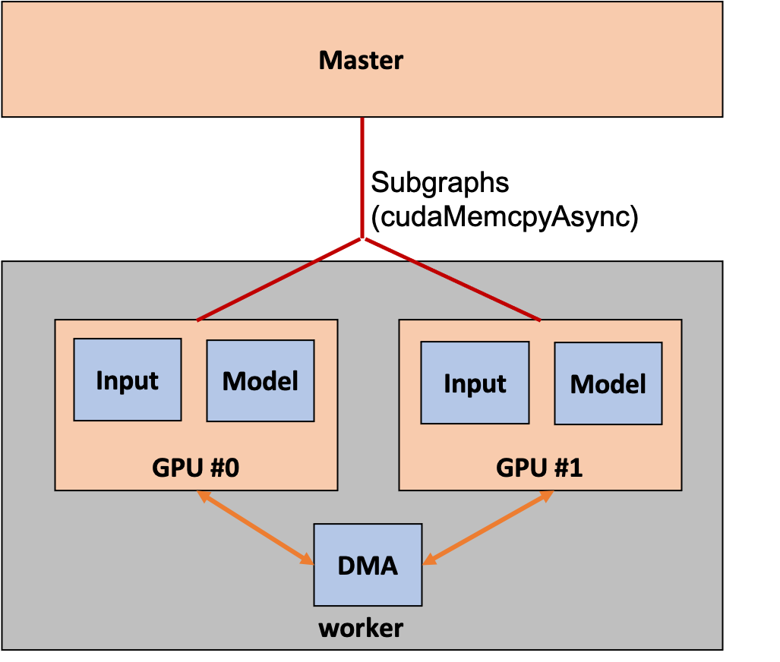

Figure . Master & worker.

There is a chief worker which is responsible for checkpointing, maintenance summary, counting steps, recovery, initializing graph variables and interactions with TensorBoard. Process schedulers holds variables and updates operations. Workers do preprocessing, calculates loss and do back-propagations.